

CDC Software Production Process

DCN: ZCH49_PRO_08P068
Version: R04.10
Location: Electronic controlled version of this procedure

Motorola Solutions CDC

Change History

Version | Review Date | Author | Description
R04.10 | May 26,2016 | Tony Zheng, Roger Lin | Minor update for organization alignment  CAR: CCMPD02078906  Review ID: 5421597213
R04.00 | Dec 27, 2013 | Lin Roger | Document update to align organization QMS update  CAR: CCMPD01848254  Review ID: 5421494361
R03.02 | Apr 8, 2011 | Lin Roger | Document updated to align with L1&2 documents and company change  CAR: CCMPD01493302  Review ID: 5421323469
R03.01 | Jan 28, 2010 | Lin Roger | Process update based on new document template and add agile related  CAR ID: CCMPD01306608  Review ID : 5421266936
R03.00 | Feb 3, 2009 | Lin Roger | Process update to integrate streamlined M-Gate specifications.  CAR: CCMPD01145705  FTR: 5421224992
R02.00 | Jan 22, 2009 | Lin Roger | Process update based on new G&PS CDC document template.  CAR: CCMPD01144331  FTR: 5421223419
R01.00 | July 10, 2008 | Lin Roger | Initial version from MSG migration  PAR: CCMPD01097167  FTR: 6069036

Approvals
Approval required: [Yes]
Name | Responsibilities | Department Name | Approval Date
Liu XiaoDong | Management Representative | CDC Quality | Jun 3, 2016  

Contents

1. Introduction 7
1.1 Purpose 7
1.2 Assumptions 7
1.3 Acronyms, Abbreviations and Definitions 7
1.4 References 7
2. Process Management 8
2.1 Process Management Overview 8
2.2 Process Modification & Maintenance 8
2.3 Process Tailoring 8
2.4 Mechanisms for Process Improvement 8
2.4.1 Fault Tracking and Reporting 8
2.4.2 Software Configuration Management (SCM) and Phase Transition 8
2.4.3 Software Quality Assurance (SQA) in the Production Process 9
2.4.4 Audit 9
3. Software Development Process 10
3.1 Software Development Process Overview 10
3.2 Commitment Process 10
3.3 Inter-group Coordination 10
3.4 Peer reviews 11
3.5 Phase Activities 11
3.6 Project Folders 11
3.7 Process Phases 11
3.7.1 Planning 11
3.7.1.1 Development Lifecycle Models 12
3.7.1.2 Project Categorization & Tailoring 20
3.7.1.3 Training 22
3.7.2 Software Requirements 23
3.7.2.1 Traceability of Software Requirements 23
3.7.3 Architecture / High Level Design 23
3.7.4 Low Level Design 23
3.7.5 Code 24
3.7.6 Unit Test 24
3.7.7 Integration 24
3.7.8 Product Test 24
3.7.8.1 Box/System Test 25
3.7.8.2 Alpha Test 25
3.7.8.3 Beta Test 25
3.5.8.4 System Integration Test (SIT) 25
3.7.9 Software Release 26
3.7.10 Maintenance 26
3.8 Phase Activities 26
3.9 Issue Escalation Procedure 32
3.9.1 High Level Product Issue Escalation 32
3.9.2 Low Level Product Issue Escalation 32
3.9.3 Process Issue Escalation 32
3.9.4 Personnel Issue Escalation 32
Appendix A - Software Design Control 33

List of Figures

Figure 3-1 Waterfall Model 13
Figure 3-2 Incremental Model 14
Figure 3-3 V-Model 15
Figure 3-4 Spiral Model 18

List of Tables

Table 3-1 Life Cycle Model Selection 20
Table 3-2 Project Categorization 22
Table 3-3 Phase Activities 27

Introduction

Purpose

The objective of the Software Production Process document is to provide a high level overview framework of the software production engineering process for CDC project teams. Considering the scenario that CDC project teams are part of technology programs and there are some variance among different technology programs process, in order to keep the integrity of program overall execution, the projects teams in CDC will put the alignment as first priority so that to get overall max efficiency and benefit.

The specific processes, guidelines, procedures, methodologies are available on the Process Web Site. This document will also provide general guide on process improvement.
.

Assumptions
This document is to be used as reference during plan a project, it needs to work together with MSI defined general process to drive product development and release successfully.

Acronyms, Abbreviations and Definitions
Refer to CDC Abbreviations.

References
- Ship Acceptance
- D-Stream
- CDC QMS

Process Management

Process Management Overview
This section will explain the steps for recommending changes to the S/W production process and discuss some common features for all process steps. Process Management is defined as the continuous process improvement in all areas related to software production.

Process Modification & Maintenance
The Software Production Process shall be maintained, reviewed and controlled by CDC quality team as SEPG core team. Recommended process changes or opportunities for improvement shall be recorded, and then reviewed, approved and incorporated.

Process Tailoring
The software production process defines the generic phases, activities and deliverables during project development lifecycle which are governed under D-Stream framework. Product development team can tailor the process based on technology process assets and program scenarios with assessment justification.
Considering the development approach evolution, some terms’ content has also been extended, such as the term of phase, it can refer to either the traditional V model development phases or the “small phase” – activities. And after MSI buy in Agile and refer to SAFe approach, there development approach will be discussed by product development needs. Basically, need to make sure the product development team know the working approach and also know the role and responsibility as well as know the input, process and output. Thus the term interpretation needs to base on the context. The final interpretation can refer to SEPG core team.

Mechanisms for Process Improvement

Fault Tracking and Reporting
Faults (including opportunities for improvement) shall be recorded and tracked until closure according to the software configuration management rules. Changes to work products after their release shall require approval.

Software Configuration Management (SCM) and Phase Transition
It is essential to keep accurate records of the activities involved in software development. The identified documents representing the activities of each major development phase are delivered to SCM archive. When the product is ready for deliver to the customer, historical information is available for the project postmortem and report.

Software Quality Assurance (SQA) in the Production Process
Contributions of the SQA function to process improvement are central and constant. SQA is a single and central unit that monitors process improvement oriented events: data reporting and analysis, postmortems, kickoffs, and project reporting. For this to be effective, SQA have enough access to project records and plans, and will be afforded an active voice in improvement decisions.

Audit
CDC Internal auditors shall conduct audit to determine the process compliance to ISO9001:2008.

Software Development Process

Software Development Process Overview
This section describes the methodologies, processes, and philosophies used in the development and verification of project deliverables. The overall software production process may be tailored to suit the unique circumstances of each particular project.
Agile development refers to corporate agile approach and SAFe is the main reference.

Commitment Process
Prior to beginning the development planning, a commitment should be obtained for the project to begin. This may be in the form of a contract book, blue book, or whatever other mechanism the business team has identified. The commitment phase is considered complete following D-Stream standard definition.

Inter-group Coordination
The purpose of Inter-group coordination is to establish a means for the software engineering group to actively participate with other engineering groups in order to develop products that satisfy the customer’s needs. This requires that 1) the customer’s requirements are agreed to by all affected groups, 2) the commitments between the engineering groups are agreed to by the affected groups, and 3) The engineering groups identify, track, and resolve inter-group issues. The affected groups will include, but not be limited to, all of the following groups:
- Software engineering
- Marketing
- Business teams
- Field engineering
- Manufacturing
- Systems engineering
- System architecture
- Electrical Engineering (RF & Digital)
The Program Manager who is responsible for the overall project schedule and coordinating the activities of all groups handles the tracking of the project. Issue resolution will also be escalated to the Program Manager, including but not limited to the following issues:
- Incompatible Schedules
- Inadequate funding
- Technical risks
- System level design and requirements defects
- System level problems
If the issue cannot be resolved by escalation to the Program Manager, then the issue is escalated to the next level until resolved.
Each phase (i.e. SRS, SPMP) should be managed such that major and minor changes are reviewed and approved by the project CCB with all affected parties represented.

Peer reviews
Formal reviews of the work product will be conducted for project defined deliverables using the Formal Technical Review process or other equivalent approach.

Phase Activities
Activities for each phase will include, but are not limited to, the following:
- Completing required work products for entry criteria
- Project tracking (and re-planning as necessary)
- Data gathering
- Metrics creation
- Defect logging and tracking
- Defect Prevention Activities

Project Folders
The purpose of the project folder is to ensure that the same information is collected and archived for all projects. All planning and tracking documents will be centrally located and easily accessible to everyone in the group. The availability of this information will also help to make tracking and planning techniques of different projects visible throughout the organization.
The project folder structure is defined in project SCMP based on project actual scenarios.

Process Phases
All work products shall be under Configuration Management, and maintained. The phases described here should refer to project SPMP. After SAFe and Agile buy in, here the term of Phase will be extended beyond the traditional V-Model/Waterfall definition, it needs to assess the scenario situation.

Planning
This is the top-level reference for everything that follows, including project plans, software requirements, designs, development and testing. The project plans are then developed. Risk management begins in this phase. The project’s decisions regarding lifecycle and development processes and project size shall be recorded in the project SPMP. A project folder containing all planning, tracking, and quality information shall be maintained.

Development Lifecycle Models
The software lifecycle model is the model for which the project manager will lead the project to design, develop, and maintain software. A process model is an instantiation of a process specification. This document specifies the process models that are compatible with the software production process specification and are available for use in software development.

Waterfall Model
Figure 3-1 Waterfall Model, is best implemented for medium or large projects where the requirements are well defined.
The Strengths of this model are:
- Easily-understood model
- Less confusion about what phase is active
- Focus is on one step at a time
- Preceding step is approved, documented and base-lined before succeeding step is taken

The Weaknesses of this model are:
- Potential delays in preceding to the next phase
- Produces too much unused documentation
- Concentrates too much on test at the end of the product for quality

Arch Design
System Req
Lo-level Design
Software Req
Code
Unit Test
Integration Test
System Test
Figure 3-1 Waterfall Model

Incremental Model
Figure 3-2 Incremental Model, is best used where requirements are known, but not necessarily fully defined. It allows corrective feedback loops and initial capability to be quickly available, and reduces technical risk of final product disaster.
The Strengths of this model are:
- Operational code delivered early in cycle
- Increments available for early customer use and feedback

The Weaknesses of this model are:
- Complexity in managing project increases
- Large number of activities occur in parallel
- Dealing with multiple customers is difficult
- Operations environment must accommodate frequent disruptions

Arch Design
System Req
Lo-level Design
Software Req
Code
Unit Test
Integration Test
Component Test
Lo-level Design
Code
Unit Test
Integration Test
Component Test
Lo-level Design
Code
Unit Test
Integration Test
Component Test
System Test
Release
Increment 1
Increment n
Increment 2
Figure 3-2 Incremental Model

V-Model
Figure 3-3 V-Model, is best for large software projects. This model facilitates the creation of the planning documents for the corresponding testing phase by phase.
During the Software Requirements Phase, in addition to the other outputs defined in the requirements phase, the developer completes a set System Test Plan.
During the Architecture Phase, in addition to the other outputs defined in the Architecture phase, the developer completes an Integration Test plan.
During the Detailed Design Phase, in addition to the other outputs defined in the Detailed Design phase, the developer completes a Unit Test Plan.
During the Code Phase, in addition to the other outputs defined in the Code Phase, the developer produces test procedures for each unit.
The Strengths of this model are:
- Requirements and System Tests are tightly coupled
- Defects are caught early on in the project
- Testing is addressed throughout the lifecycle of the product

The Weaknesses of this model are:
- Appearance of little progress
Project Planning
System
Requirements
Architecture
Design
Detailed Design

Code
Integration Test
System Test
Unit Test
Maintenance/
Operation
- Much preliminary work
Figure 3-3 V-Model

Spiral Model
Figure 3-4 Spiral Model, is necessary when the major risks are being considered, and the technical feasibility of the product is unclear. This model is effective if there are many technical risks in the project, because after each prototype a decision must be made as to the feasibility of the project.
The Strengths of this model are:
- Each phase focuses on alternative approaches and evaluation
- Emphasizes risk management and prototyping
- Has incorporated mid-course corrections
- When lowest risk approach surfaces, proceed using waterfall model

The Weaknesses of this model are:
- Uses step-by-step approach
- Needs long-range goals set for funding and support
- Lacks simplicity
- Complicates implementation of waterfall model
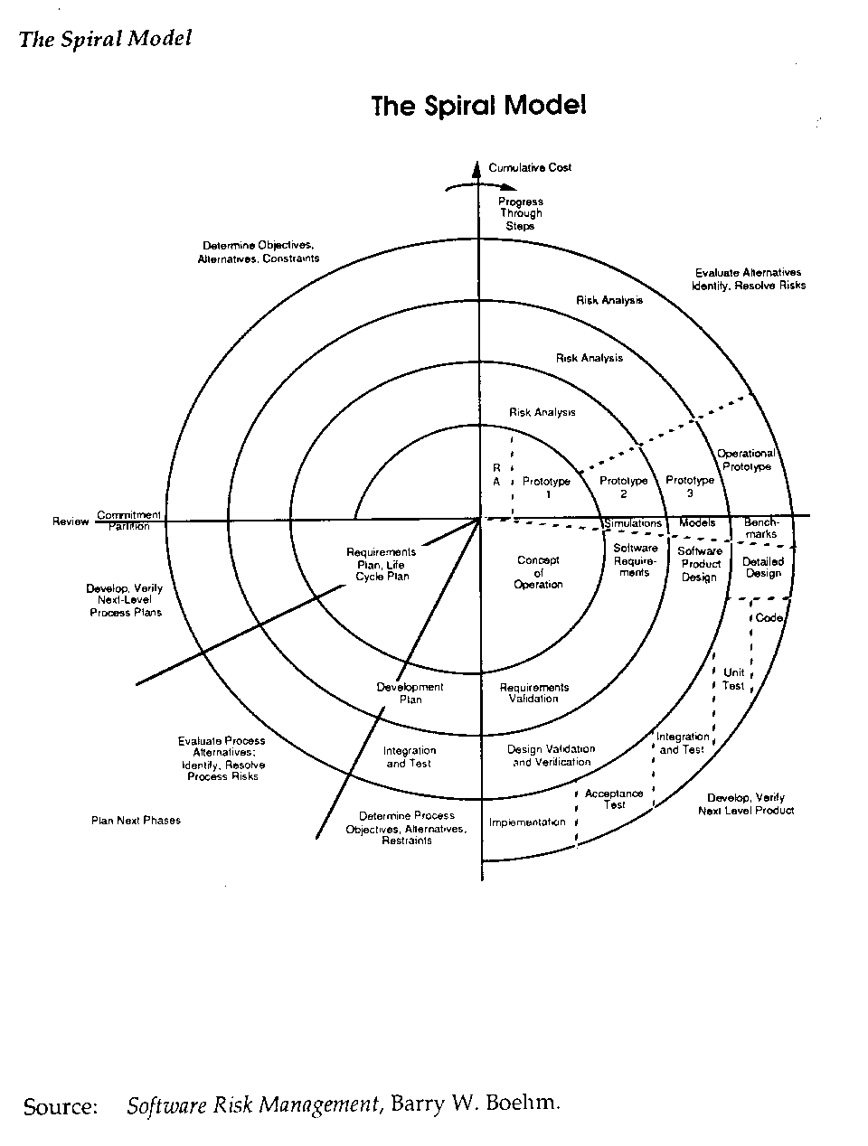Figure 3-4 Spiral Model

Iterative and Incremental
Iterative and Incremental development is any combination of both iterative method and incremental build model for software development, to develop a system through repeated cycles (iterative) and in smaller portions at a time (incremental). And it is essential parts of the agile software development framework.
Iterative and Incremental development is contrast with waterfall development. Waterfall development completes the project-wide work-product of each phase in one step before moving to the next phase in the next step. Business value is delivered all at once, and only at the very end of the project. However, Iterative and Incremental development slices the system functionality into increments (iteration/sprint), in each increment, a slice of functionality is delivered through cross-phase work, from requirement to test.
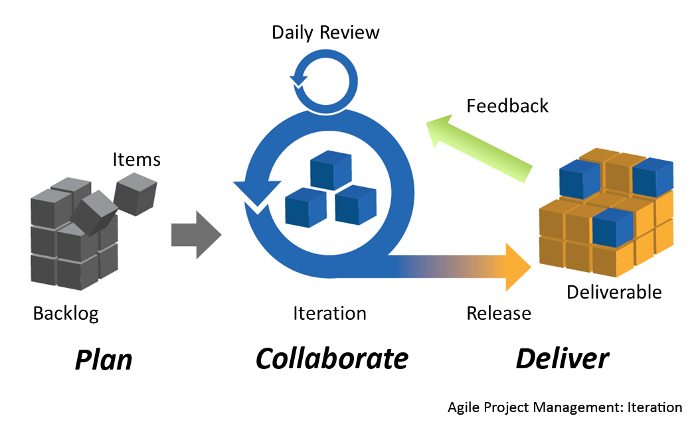Figure 3-5 Iterative Model

SAFe

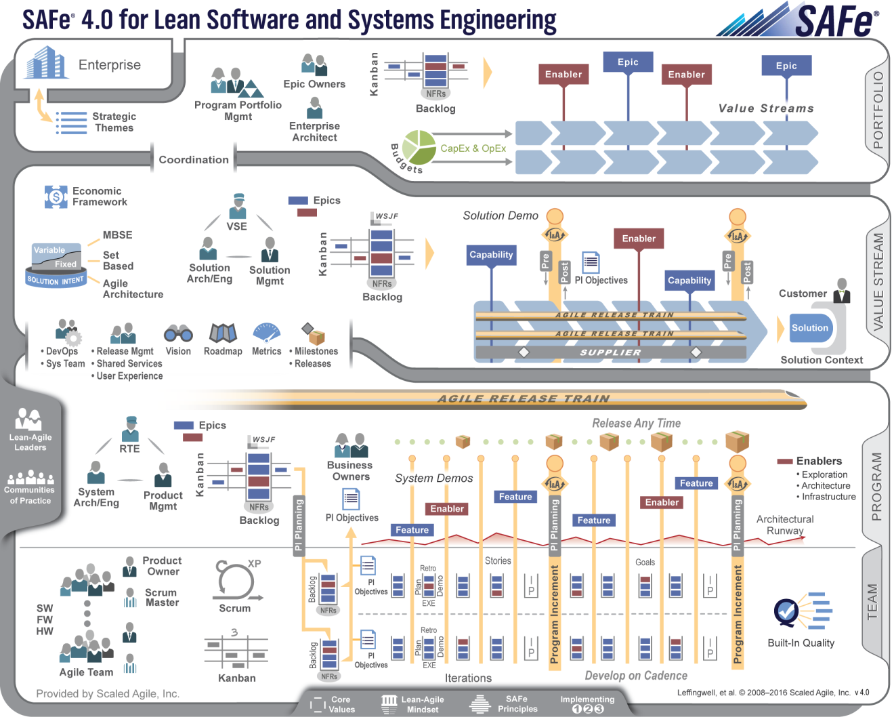

Development Lifecycle Model Selection
The following table lists criteria to be considered when selecting a project Life Cycle model.

Criteria | Waterfall | Incremental | V Model | Spiral | Iterative and Incremental | SAFe
Project complexity is expected to be; | Low | Medium | High or Med | High | High | High
The ease of the model use is; | Simple | Moderate | Moderate | Complex | Moderate | Complex
The requirements are expected to be; | Stable | Flexible | Stable | Unstable | Flexible | Unstable
The desired cost of development is; | Low | Medium | Medium | Medium | Medium | High
The cost of future upgrades will be; | High | Medium | Low | Low | Low | Low
The expected longevity of product is; | Long | Average | Long | Long | Long | Long
The required resources at startup are; | Low | Some | Many | Many | Some | Fixed
Table 3-1 Life Cycle Model Selection

Project Categorization & Tailoring
Projects are categorized based on expected effort and associated risks and the following project category is the reference for project tailoring consideration. See the categories and required deliverables listed in table 3-2. Tailoring is the mechanism a project shall use to create a process and deliverables that best meets its needs. Tailoring need to be reviewed approved and recorded.
The guidelines to categorize a project based on its expected effort and risk are listed below. The guidelines also contain tailoring criteria for the list of required deliverables.
Category 1: Fix. The fix is being sent to a customer for field correction. Effort is less than 2 staff months.
Category 2: Small Project. A Category 2 project is one in which the development effort is calculated to be 12 staff months or less. If the development effort is greater than 12 staff months, or risks associated with the project are deemed by management to be unusually high use Category 3.
Category 3: Medium Project. A category 3 project is one in which the development effort is calculated to be more than 12 staff months but no more than 36 staff months. If the development effort is greater than 36 staff months, or the risks associated with the project are deemed by management to be unusually high use Category 4.
Category 4: Large Project. Category 4 projects are those that will take more than 36 staff months to complete. Projects in this category are considered normal size projects and, as such, by default, need to follow the Software Production Process.
The effort number listed above is just a reference for team to consider the deliverables, it is not a “black or white” threshold. The project business scenarios and project management triangle trade-off may dominate the overall plan.
Based on the classification, the following deliverables should be generated with appropriate tailoring per project characteristics and the tailoring justification should be recorded.
Required Deliverables 1,2,3 | Category Project  16 26 36 46
Software Quality Assurance Plan |  |  | Y | Y
Software Project Management Plan |  |  | Y | Y
Software Configuration Management Plan | Y4 | Y | Y | Y
Requirements Document | Y4 | Y | Y | Y
Work Breakdown Structure (Schedule) |  | Y | Y | Y
Risk Management Plan |  | Y | Y | Y
Traceability^{,8,9} | Y4 | Y | Y | Y
Design Documentation | Y4 | Y | Y | Y
Unit Test Documentation9 | Y4 | Y | Y | Y
Integration Test Documentation9 | Y4 | Y | Y | Y
Box/System Test Documentation9 | Y4 | Y | Y | Y
End user documentation (RSS, Service, & User manuals)9 | Y7 | Y7 | Y7 | Y7
Release Documentation9^{,10} | Y4 | Y | Y | Y
Post Mortem Documentation |  |  | Y | Y
Table 3-2 Project Categorization
- The documents, forms, plans, and code must be placed under configuration management as soon as created and must be maintained per the project’s SCMP.
- The documents only need to be created where applicable but must be updated throughout the project.
- All deliverables must be reviewed or equal method.
- Fix releases should use documentation of the primary release. Updates can be performed after code is released if required.
- Can be in any form e.g. C3, marketing request, or manager request, as opposed to a separate formal document. However, it must contain the scope of the project, the effort required, project category and a commitment from senior management in the form of a signature or email.
- The existing ’artifacts’ must be updated where applicable (applies to all work products regardless of whether or not a “Y” has been specified in that particular category).
- As appropriate. May be in the form of an "insert".
- For Traceability, Requirement will be traced to Test deliverables or equal approach.
- Not required for demos, Prototypes for Proof of concepts.
- These include Release Notes.
- The category in the table above is not a fixed one when SAFe and Agile introduced and need to assess the scenario situations based on the standard needs as well as MSI standards.

Training
As part of the planning phase, the training requirements for the project shall be determined. This includes conferences and training for new tools as well as skills necessary to complete the project. Training needs and development for the organization shall follow the organization training process

Software Requirements
The SW requirements are allocated in the Contract Book, TRS and/or TRD. The SW development group is a stakeholder in all these high-level requirement documents. The detailed SW product requirements (SRS) and all SW plans, work products and activities are based on these high level marketing and system requirements. The business team and the SW group together have the responsibility of making sure all the high-level requirements are allocated to software and within different SW functional areas. During the Software Requirements phase, the developer defines a complete set of software requirements, interface requirements, and program test requirements into the Software Requirements Specification (SRS). Depending on the Software Development Lifecycle model, this document completely and precisely interprets the customer’s requirements and constraints, according to the amount of information available to the developers at the time. Requirements specify what the product is and what it does for the Customer, but it does not specify how.

Traceability of Software Requirements
General speaking, requirements will be identified using requirement tags or other ID approach to distinguish from each other and also make sure the product requirements is complete.
Project team are suggested to use requirement management tool (eg:DOORS, Reqpro, Excel) to improve requirement management efficiency, and the requirement traceability needs to set up at the right level to make sure there is no missing and no overlapping.

Architecture / High Level Design
The Architecture or High-Level Design activity logically decomposes the system requirements specified in the SRS into Modules. It defines their interfaces and the data and control flows between them.
For both embedded and GUI based application designs, RT Rational Rose, SDL, Flow chart or other similar tools shall be used.
Note:
Architecture/High Level Design is not a mandatory phase which is based on the project actual scenarios as well as the justification to make sure the requirement can be implemented. If no architecture/high level design phase, project team use design phase as a common one including both architecture/high level design.

Low Level Design
The Low Level Design specifies the formats, inputs, outputs and algorithms of the modules in enough detail to support code development and unit testing.
For both embedded and GUI based application designs, RT Rational Rose, SDL, Flow chart, MSCs or other similar tools shall be used.
Note:
Because of the OO design method deployment (Such as Rational Rose-RT), the design may be distributed per the tool guide, and the generated report can be a reference equal to traditional design.

Code
The code activity translates the detailed design into executable code. This will be the implementation of the low-level design. Depending on the language used, the corresponding coding standards will be adhered to.
Note:
Because of the OO implementation method deployment(Such as Rational Rose-RT), the code may be distributed per the tool guide, and the generated report can be a reference equal to traditional source code.

Unit Test
The Unit Test plan and associated tests are implemented based on project actual scenarios. In some cases, Unit Test is covered in adjacent test phases.

Integration
The integration phase consists of module integration as well as subsystem integration. Integration testing validates the interfaces between related modules and related sub-systems in order to demonstrate that they can be combined to correctly perform basic required functions. The integration test plan and associated tests are implemented based on project actual scenarios.
Notes: In some cases, Integration Test is covered in Feature Test. Generally development team will use Feature test to cover both Unit test and integration test before IR. Feature test can cover the functionality of Unit Test and Integration Test.

Product Test
The product test phase consists of Box/System Testing, Alpha Testing, Beta Testing and SITS Testing as determined in the project SPMP. The tests are to verify that the product behaves as described in the Product Requirements and Software Requirements.
Because of organization assignment, CDC has no Box Test/System Test, Alpha Testing and Beta Testing team besides providing support during the test phase. In this SPP, the phase is listed as reference.

Box/System Test
The Box/System test phase is used to black-box test the integrated software units as a whole entity. The Box/System test phase consists of Box/System test passes as determined in the project SPMP or Box/System Test Plan. The tests are to verify that the integrated units behave as described in the project SRS. The test release built for each Box/System test pass should incorporate requirements identified in the project SRS and issues found in previous passes of the Box/System test.
A test pass will be dictated by project Box/System Test Plan, which should include testing approaches for changes made to the software or hardware associated with previous test passes. The test pass may be stopped immediately if failure or impaired performance of any of the dependant systems becomes apparent.

Alpha Test
An Alpha test is designed to test the product, as a customer would use the product. Alpha testing is to be performed with the system installed and operating in the target environment, but not performed by the customers themselves. This will allow the developers to see the product performing in the designated environment without the problems being discovered by customers. The Alpha tests are performed according to the testing procedures. The software build for this test is identified in the test plan, incorporating new requirements and code updates. A new test run will be required if any changes are made to the software or hardware associated with the test.

Beta Test
A Beta Test is used on customer’s system, and is designed to test the product, as a customer would use the product. This allows the developers to closely monitor the system, find potential problems before the problems are shipped to other customers, and verify that this is the right product for the customer, and get the customer’s acceptance. Beta testing is declared in the SPMP and can only be waived with the appropriate technical rationale. This should also be stated in the SPMP. To release for Beta, follow the beta section in the Release guideline and complete the appropriate section of the SQA Software Release Checklist.

3.5.8.4 System Integration Test (SIT)
A Systems Integration Test (SIT) phase is used to perform black box test for the entire integrated subscriber infrastructure system. In conjunction with the System Enhancement Release (SER) process, SIT is determined by the project plan. The tests are to verify that the product will operate as described in the System and Software Requirements and in accordance with the test procedures with as many standard infrastructures as possible. The software builds for this testing is identified in the test plan. Test runs are scheduled when there are changes made to the software and hardware associated with the testing. If the products are to be certified via the SER process, then there is a set schedule when builds are submitted for testing.

Software Release
The software release activity is performed via a Release Readiness Review according to the Release Guidelines Ship Acceptance. The Release Guidelines shall be followed, and the Ship Acceptance Checklist must be completed.
If project release is not owned by the CDC project team, CDC will provide support, if applicable

Maintenance
The maintenance phase of the development shall be considered, staffed, and planned for in the original project plan.

Phase Activities
The following table demonstrates what the typical entry and exit requirement are as well as the standard activities and deliverables occurring in each phase. Based on this guideline and project characteristic, each project’s SPMP will contain the specific information that is expected from each phase with appropriate tailoring.
For Agile based development approach, because it focus on iterative and incremental development, this the phase activities listed below could be partial within one iteration/sprint, however, from end to end, the phase activities can still be a key reference.
Table 3-3 Phase Activities

Cell | Project Planning Phase | Origin
Entry | - Commitment of resources from business unit  - Preliminary Product Description or Preliminary TRD  - Marketing Analysis  - Historical data  - High level Requirements Document, Technical Requirements Document & Software Requirements Document  - Desired Product and Deployment Date  - Project Kick off Meeting  - Preliminary HW architecture Platform | - Business CCB  - Marketing Group  - Marketing  - Historical Database  - Project Definition Phase  - Business CCB  - Project Manager  - HW Group
Exit | - Reviewed Product Description or Preliminary TRD  - SPMP (Software Project Management Plan)  - SQAP (Software Quality Assurance Plan)  - SCMP (Software Configuration Management Plan)  - STP (System Test Plan), if applicable  - Reviewed HW architecture platform  - Project Schedule  - Baseline Staffing Plan | - Program Manager  - Project Manager  - SQA  - Project CM  - System Test Manager  - Program Design Review  - Project Manager  - Project Manager

Cell | Requirements Analysis Phase | Origin
Entry | - Reviewed Preliminary product description or preliminary TRD  - High level requirements and/or Interface documents - examples are as follows:  - Ergonomics Specification  - SW/HW Interaction and/or HW architecture and platform  - SRD - System Requirements Document  - CQCM SRs  - Requirements Process Documents and SRS templates | - Project Definition Phase  - Development Engineers  - Marketing  - Electrical HW group and SW Development  - Project Definition Phase  - Program Management  - Dev. Engineers
Exit | - Software Requirement Specification Document (SRS).  - Updated SPMP, SQAP, SCMP, STP (if required)  - Any new interface requirement request has been made to other groups.  - Start Test Plan and test procedures. (very high level)  - Start Test Procedure Specification and Test Design Specification  - Handoff SRSs to integration and system test.  - Phase audit, if applicable | - Dev. Engineers  - Project Team  - Project Team  - Dev. Engineers  - Dev. Engineers  - Project Manager  - SQA
Cell | Architecture/High Level Design Phase | Origin
Entry | - Software Requirement Specification Document  - Software Architecture Document, if applicable  - Requirement Allocation | - Dev. Engineers  - Project Manager  - Project Manager
Exit | ALL:  - High Level Design Document  - Updated SPMP,SCMP,SQAP, STMP(if required)  - Updated but not complete Test Plan & Procedures  - Traceability if applicable  - Phase audit, if applicable | - Dev. Engineers  - Project Team  - Dev. Engineers  - Dev. Engineers  - SQA

Cell | Low Level Design Phase | Origin
Entry | - High Level Design Document  - Software Requirements Specification  - Software Architecture Documents, if applicable  - Hardware Architecture Documents, if applicable | - Dev. Engineers  - Project Manager
Exit | - Low Level Design Document  - Traceability if applicable  - Updated SPMP, SCMP, SQAP, STP (if required)  - Updated but not complete Test Plan and Test Procedures  - Phase audit, if applicable | - Dev. Engineers  - Dev. Engineers  - Project Manager  - Project Team  - SQA

Cell | Coding and Unit Test/Feature Test Phase | Origin
Entry | ALL:  - Software Requirement Specification  - Software Architecture Document , if applicable  - High level and Low level design document, if applicable | - Dev. Engineers  - Project Manager
Exit | ALL:  - Code Modules  - Traceability if applicable  - Test Results  - Updated SPMP, SCMP, SQAP,STP (if required)  - Phase audit, if applicable | - Dev. Engineers  - Dev. Engineers  - Dev. Engineers  - Project Team  - SQA

Cell | Integration/Feature Test | Origin
Entry | - Integration test plan if required  - Test procedures | - Dev. Engineers  - Dev. Engineers
Exit | - Traceability if applicable  - Summary of test results  - Updated SPMP, SCMP SQAP, STP (if required)  - Test procedures for new features  - Phase audit, if applicable | - Dev. Engineers  - Dev. Engineers  - Project Team  - Dev. Engineers  - SQA

Cell | Product Test | Origin
Entry | - STP  - Requirement Documents, SRS, etc.  - Test Readiness Review Checklist, if applicable  - Traceability Matrix | - Test Engineers  - Dev. Engineers  - Test Engineers  - Test Engineers
Exit | - Defect Reports  - Closed Defects  - System Test Report  - Updated STP  - Updated SPMP, SCMP, SQAP (if required)  - Ship Acceptance Meeting | - Test Engineers  - Dev/Test. Engineers  - Test Engineers  - Dev. Manager  - Project Team  - Project Manager

Cell | Software Release | Origin
Refer to Ship Acceptance and D-Stream requirements

Cell | Maintenance | Origin
Refer to Related MOL work procedure.

Note: Aftr SAFe and Agile buy-in, the phase and phase activity is an overall reference and need to be assessed based on the scenario situations.

Issue Escalation Procedure

High Level Product Issue Escalation
If high level product issues are encountered during the project lifecycle, issue escalation should be done in the following order:
- To direct manager.
- To marketing manager.
- To product manager.

Low Level Product Issue Escalation
If low level issues are encountered during the project lifecycle, issue escalation should be done in the following order:
- To direct manager.
- To project manager.
- To product manager.

Process Issue Escalation
If process issues are encountered during the project lifecycle, issue escalation should be done in the following order:
- To direct manager.
- To SQA manager.

Personnel Issue Escalation
If issues are encountered during the project lifecycle, issue escalation should be done in the following order:
- To direct manager.
- To Human Resources.

Software Design Control

The Software Design Control is based on ISO9001:2008 requirement and align with design policy which is addressed in the Quality Manual. And it provides the process environment boundary for software production process. The software production process is implemented through D-Stream framework which is addressed in this software design control session. The purpose of this procedure is to establish the mapping between D-Stream development framework and the ISO9001:2008 Section 7.3 Design and Development.
- This procedure applies to project from Business Case Development Phase (i.e. D3), through the product development stage until the developed Product is granted Ship Acceptance status (i.e. at D1) D-Stream Principle:The Core Team is empowered and responsible to own and drive the program
- Do what your program needs – No more, no less
- Be FLEXIBLE and AGILE
For detail, please refer to https://converge.motorolasolutions.com/groups/d-stream

Software Development Process List
Refer to CDC QMS webpage

